## 3 Designing Data Processing Systems

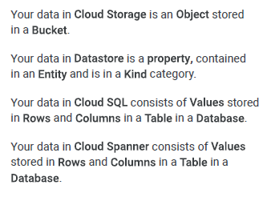

The storage options and databases mentioned in the image are each optimized for different use cases:

1. **Cloud Storage**: Optimized for storing unstructured data that can be accessed from anywhere on the internet. It's ideal for serving website content, storing data for archival and disaster recovery, or distributing large data objects to users via direct download.

2. **Datastore**: This is a highly scalable NoSQL database designed for application backends. It's optimized for automatic scaling, high performance, and ease of application development. It is suitable for storing and retrieving non-relational data, which can then be queried like a traditional database.

3. **Cloud SQL**: This is a fully-managed relational database service for MySQL, PostgreSQL, and SQL Server. It's optimized for web frameworks and existing applications that require a relational database, offering standard SQL capabilities with the added benefits of managed services.

4. **Cloud Spanner**: Spanner is a fully managed, mission-critical, relational database service that offers transactional consistency at a global scale, schemas, SQL (ANSI 2011 with extensions), and automatic, synchronous replication for high availability. It's optimized for large-scale database applications, such as inventory management, financial transactions, and control systems, where the database needs to be globally consistent and highly available.

Each of these storage options is designed to handle different aspects of data storage needs, from binary large object storage in Cloud Storage to complex, multi-structured data in NoSQL options like Datastore, to structured data in SQL databases like Cloud SQL and globally distributed databases like Cloud Spanner.